**OPTIMIZING FLIGHT BOOKING DECISIONS THROUGH MACHINE LEARNING PRICE PREDICTIONS**

**TEAM ID:NM2023TMID25315**

**GOWTHAM KUMAR R : 6B83CD1E9F4E57A243460987F9AA297**

**HARIHARAN M : BFCB43ECF3BAE6892ED40C4D65CF189F**

**GIRIDHARAN A : AA80B5A03418642932F4AAFEEF9AAD70**

**JAGADEESAN P : 2667C07816096F8AB374C3FD97CA3217**

**SUBMITTED FOR THE PROJECT UNDER THE**

**NAAN MUDHALVAN - SMARTINTERNZ**

**PROGRAM**

|  |  |  |
| --- | --- | --- |
| **1.** | **INRODUCTION** |  |
|  | 1.1 PROJECT OVER VIEW |  |
|  | 1.2 PROJECT PURPOSE |  |
| **2.** | **PROBLEM DEFINITION & DESIGN THINKING** |  |
|  | 2.1 EMPHATHY MAP CANVAS |  |
|  | 2.2 IDEATION AND BRANSTORMING |  |
| **3.** | **RESULTS** |  |
|  | 3.1 OUTPUT OF THE PROJECT |  |
| **4.** | **ADVANTAGES & DISADVANTAGES** |  |
|  | 4.1 ADVANTAGES |  |
|  | 4.2 DISADVANTAGES |  |
| **5.** | **APPLICATIONS** |  |
| **6.** | **CONCLUSION** |  |
| **7.** | **FUTURE SCOPE** |  |
| **8.** | **APPENDIX** |  |
|  | 8.1 SOURCE CODE |  |
|  | 8.2 GITHUB LINK & PROJECT DEMO LINK |  |

**INTRODUCTION**

**1.1 Overview**

The flight ticket buying system is to purchase a ticket many days prior to flight take-off so as to stay away from the effect of the most extreme charge. Mostly, aviation routes don’t agree this procedure. Plane organizations may diminish the cost at the time, they need to build the market and at the time when the tickets are less accessible. They may maximize the costs. So, the cost may rely upon different factors. To foresee the costs this venture uses AI to exhibit the ways of flight tickets after some time. All organizations have the privilege and opportunity to change its ticket costs at any time. Explorer can set aside cash by booking a ticket at the least costs. People who had travelled by flight frequently are aware of price fluctuations. The airlines use complex policies of Revenue Management for execution of distinctive evaluating systems. The evaluating system as a result changes the charge depending on time, season, and festive days to change the header or footer on successive pages. The ultimate aim of the airways is to earn profit whereas the customer searches for the minimum rate. Customers usually try to buy the ticket well in advance of departure date so as to avoid hike in airfare as date comes closer. But actually, this is not the fact. The customer may wind up by giving more than they ought to for the same seat.

**1.2 Purpose**

1. To get effective price for the customers.
2. Make UI user friendly.
3. Use of various ML methods to know more about dataset and get accurate results.
4. The aim of the project is:
5. The aim is to gain complete knowledge of “Data Science and Machine Learning”.
6. To study and gain knowledge about different algorithms in Machine Learning.
7. To get effective accurate price of flight fare.
8. To study flights prices ups & downs according to routes and on different days.
9. Creating effective user-friendly UI design.
10. Finding solutions for mitigation of defects

**PROBLEM DEFINITION AND DESIGN THINKING**

**2.1 EMPHATHY MAP**

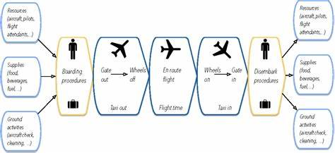

**.**

**2.2 IDEATION AND BRAINSTORMING MAP**

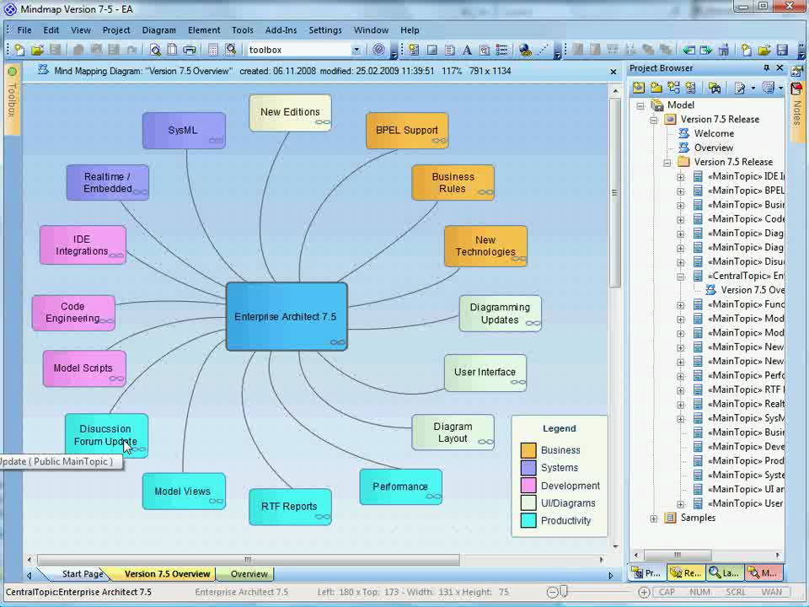

**RESULTS**

3.1 Output of the project

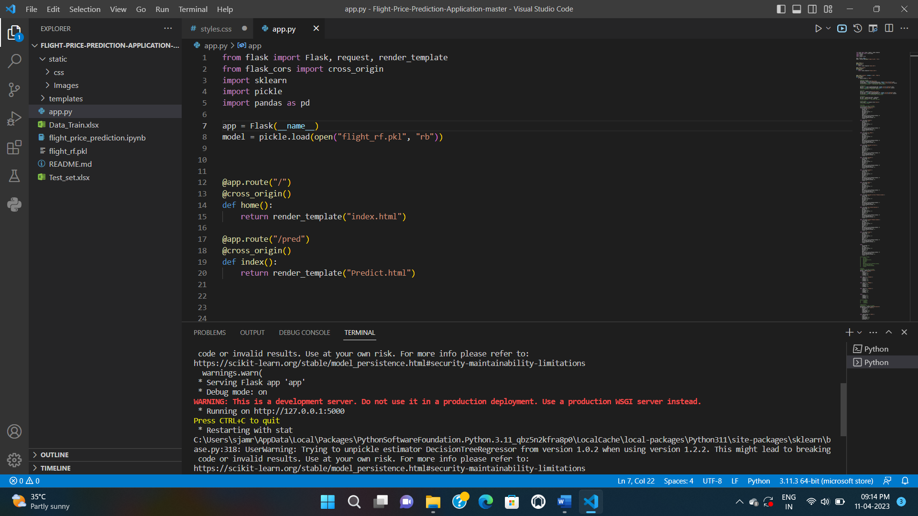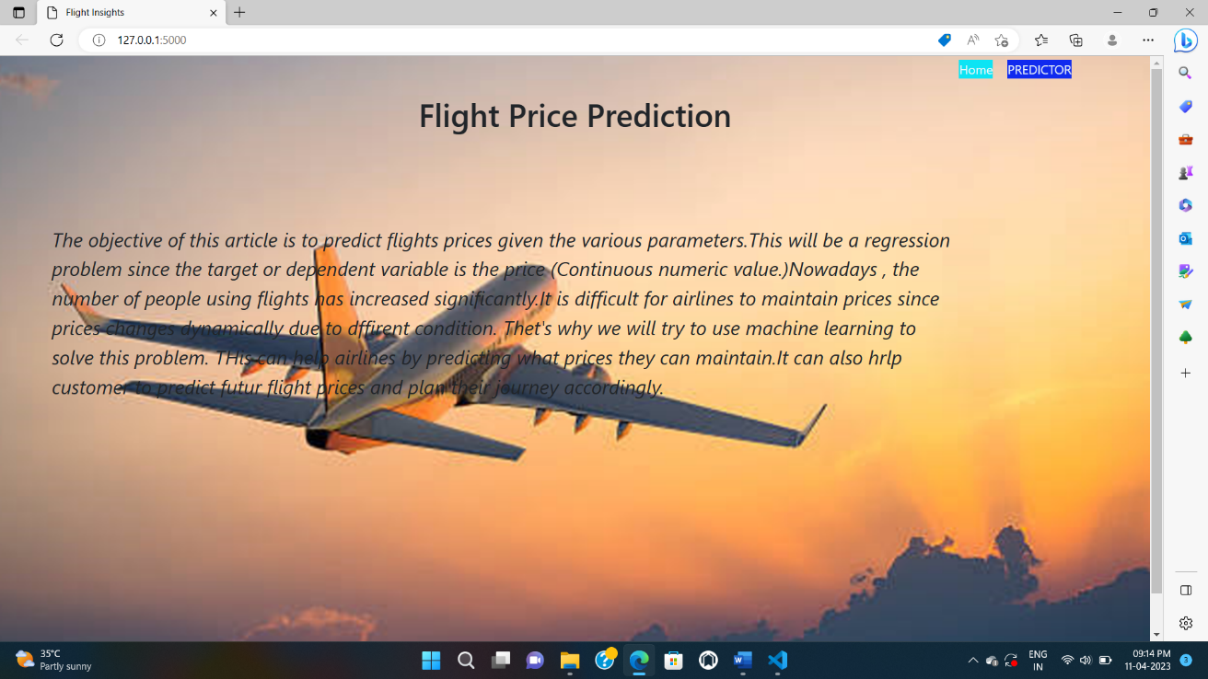

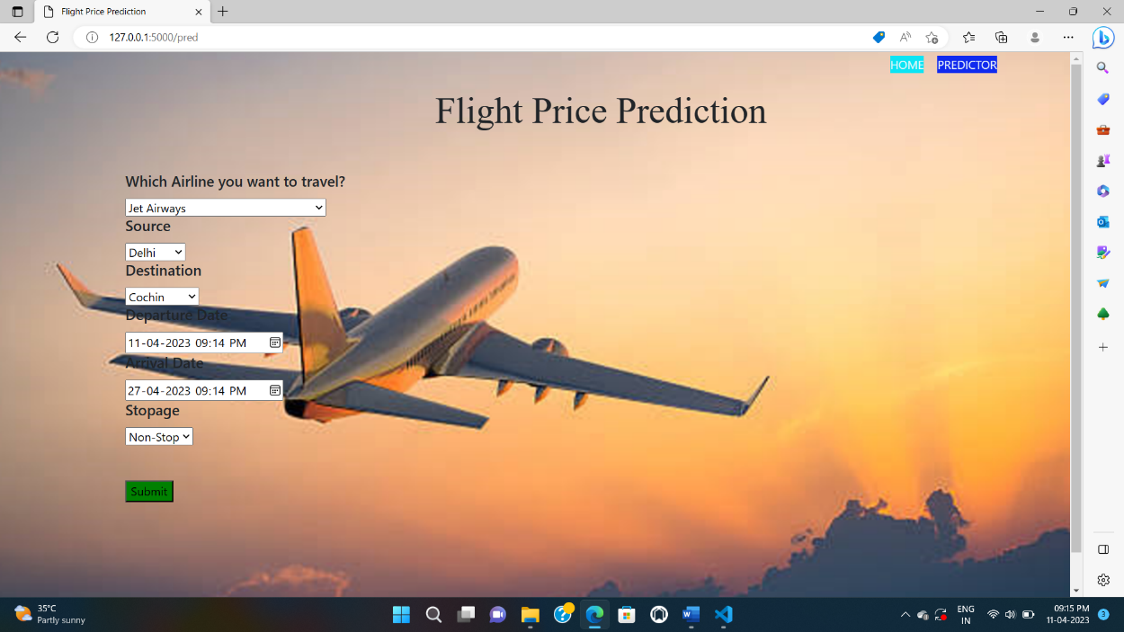

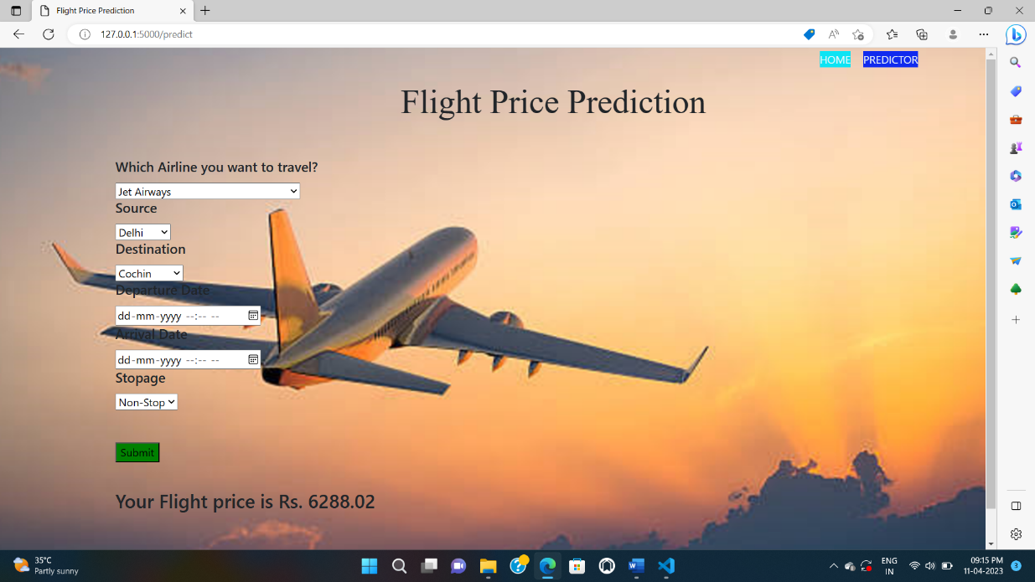

**ADVANTAGES**

1. Improved Accuracy: Machine learning algorithms can analyze large amounts of historical flight data and identify patterns that may not be easily recognizable to humans. This can help predict flight prices with a higher level of accuracy than traditional methods.
2. Cost Savings: Accurately predicting flight prices can help travelers save money by enabling them to book flights when prices are low. Additionally, airlines can use these predictions to optimize their pricing strategies and increase revenue.
3. Real-time Updates: Machine learning algorithms can continuously analyze flight data and update predictions in real-time. This can help travelers make informed decisions about when to book flights and airlines to adjust their pricing strategies.
4. Customized Recommendations: Machine learning algorithms can analyze a traveler's historical flight data and make personalized recommendations based on their travel history and preferences.
5. Scalability: Machine learning algorithms can handle large amounts of data and can be scaled up to handle larger datasets as needed.

**DISADVANTAGES**

1. Limited data availability: Flight price prediction models require a large amount of data to accurately predict prices. However, data can be limited, especially for newer or less frequently traveled routes, making it difficult to train models effectively.
2. Dependence on historical data: Machine learning models rely heavily on historical data to make predictions. This means that they may not be able to accurately predict prices during periods of economic or industry upheaval, such as during a pandemic.
3. Lack of transparency: Machine learning models can be difficult to understand and interpret, making it hard to identify and address any biases or errors in the predictions. This can lead to a lack of trust in the predictions and the model itself.
4. Inaccurate or outdated data: If the data used to train the machine learning model is inaccurate or outdated, the predictions may also be inaccurate. This can be a particular concern in rapidly changing industries like travel.
5. Unforeseen factors: Flight prices can be affected by a range of factors, including weather, political events, and global economic conditions. Machine learning models may not be able to account for all of these factors, making it difficult to accurately predict prices.

**APPLICATIONS**

1. Help travelers make informed decisions: Flight price prediction can help travelers to plan their trips and make informed decisions about when to book their flights. By providing accurate and timely information on expected price changes, travelers can save money and avoid overpaying for flights.
2. Improve revenue management for airlines: Airlines can use flight price prediction models to optimize their pricing strategies and maximize revenue. By predicting demand and adjusting prices accordingly, airlines can increase profitability while also ensuring that their flights are well-attended.
3. Assist travel agencies: Travel agencies can also benefit from flight price prediction models by offering more competitive pricing to their customers. By using machine learning to predict price changes, travel agencies can ensure that they are offering the best possible deals to their clients.
4. Provide insights into market trends: Flight price prediction models can provide insights into market trends and help airlines and travel companies to understand consumer behavior. This can be useful for identifying new business opportunities and developing targeted marketing strategies.
5. Enhance customer experience: By offering accurate and timely price predictions, airlines and travel companies can enhance the customer experience and build trust with their customers. This can lead to increased loyalty and repeat business over time

**CONCLUSION**

Machine Learning algorithms are applied on the dataset to predict the dynamic fare of flights. This gives the predicted values of flight fare to get a flight ticket at minimum cost. The values of R-squared obtained from the algorithm give the accuracy of the model. In the future, if more data could be accessed such as the current availability of seats, the predicted results will be more accurate. Finally, we conclude that this methodology is not preferred for performing this project. We can add more methods, more data for more accurate results.

**FUTURE SCOPE**

Flight price prediction using machine learning has significant potential in the future, as it can help travelers make informed decisions about flight bookings and help airlines optimize their pricing strategies. Here are some potential future scopes for flight price prediction using machine learning:

1. Improved accuracy: With the increasing availability of data and advancements in machine learning algorithms, flight price prediction models are expected to become more accurate in the future. This can help both travelers and airlines make more informed decisions.
2. Real-time pricing: Real-time pricing models can help airlines adjust ticket prices in real-time based on factors such as demand, availability, and competition. This can result in better revenue management for airlines and potentially lower prices for travelers.
3. Personalized pricing: Machine learning algorithms can help airlines offer personalized pricing based on factors such as customer preferences, loyalty, and past booking history. This can result in a more personalized and targeted pricing strategy for airlines.
4. Integration with travel booking platforms: Flight price prediction models can be integrated with travel booking platforms such as Expedia, Kayak, and others. This can provide travelers with real-time price updates and recommendations based on their preferences.
5. Use of alternative data sources: Machine learning algorithms can be trained on alternative data sources such as social media, weather data, and economic indicators to provide more accurate price predictions. This can result in a more comprehensive pricing strategy for airlines.

**APPENDIX**

8.1 SOURCE CODE

from flask import Flask, request, render_template

from flask_cors import cross_origin

import sklearn

import pickle

import pandas as pd

app = Flask(__name__)

model = pickle.load(open("flight_rf.pkl", "rb"))

@app.route("/")

@cross_origin()

def home():

    return render_template("index.html")

@app.route("/pred")

@cross_origin()

def index():

    return render_template("Predict.html")

@app.route("/predict", methods = ["GET", "POST"])

@cross_origin()

def predict():

    if request.method == "POST":

        # Date_of_Journey

        date_dep = request.form["Dep_Time"]

        Journey_day = int(pd.to_datetime(date_dep, format="%Y-%m-%dT%H:%M").day)

        Journey_month = int(pd.to_datetime(date_dep, format ="%Y-%m-%dT%H:%M").month)

        # print("Journey Date : ",Journey_day, Journey_month)

        # Departure

        Dep_hour = int(pd.to_datetime(date_dep, format ="%Y-%m-%dT%H:%M").hour)

        Dep_min = int(pd.to_datetime(date_dep, format ="%Y-%m-%dT%H:%M").minute)

        # print("Departure : ",Dep_hour, Dep_min)

        # Arrival

        date_arr = request.form["Arrival_Time"]

        Arrival_hour = int(pd.to_datetime(date_arr, format ="%Y-%m-%dT%H:%M").hour)

        Arrival_min = int(pd.to_datetime(date_arr, format ="%Y-%m-%dT%H:%M").minute)

        # print("Arrival : ", Arrival_hour, Arrival_min)

        # Duration

        dur_hour = abs(Arrival_hour - Dep_hour)

        dur_min = abs(Arrival_min - Dep_min)

        # print("Duration : ", dur_hour, dur_min)

        # Total Stops

        Total_stops = int(request.form["stops"])

        # print(Total_stops)

        # Airline

        # AIR ASIA = 0 (not in column)

        airline=request.form['airline']

        if(airline=='Jet Airways'):

            Jet_Airways = 1

            IndiGo = 0

            Air_India = 0

            Multiple_carriers = 0

            SpiceJet = 0

            Vistara = 0

            GoAir = 0

            Multiple_carriers_Premium_economy = 0

            Jet_Airways_Business = 0

            Vistara_Premium_economy = 0

            Trujet = 0

        elif (airline=='IndiGo'):

            Jet_Airways = 0

            IndiGo = 1

            Air_India = 0

            Multiple_carriers = 0

            SpiceJet = 0

            Vistara = 0

            GoAir = 0

            Multiple_carriers_Premium_economy = 0

            Jet_Airways_Business = 0

            Vistara_Premium_economy = 0

            Trujet = 0

        elif (airline=='Air India'):

            Jet_Airways = 0

            IndiGo = 0

            Air_India = 1

            Multiple_carriers = 0

            SpiceJet = 0

            Vistara = 0

            GoAir = 0

            Multiple_carriers_Premium_economy = 0

            Jet_Airways_Business = 0

            Vistara_Premium_economy = 0

            Trujet = 0

        elif (airline=='Multiple carriers'):

            Jet_Airways = 0

            IndiGo = 0

            Air_India = 0

            Multiple_carriers = 1

            SpiceJet = 0

            Vistara = 0

            GoAir = 0

            Multiple_carriers_Premium_economy = 0

            Jet_Airways_Business = 0

            Vistara_Premium_economy = 0

            Trujet = 0

        elif (airline=='SpiceJet'):

            Jet_Airways = 0

            IndiGo = 0

            Air_India = 0

            Multiple_carriers = 0

            SpiceJet = 1

            Vistara = 0

            GoAir = 0

            Multiple_carriers_Premium_economy = 0

            Jet_Airways_Business = 0

            Vistara_Premium_economy = 0

            Trujet = 0

        elif (airline=='Vistara'):

            Jet_Airways = 0

            IndiGo = 0

            Air_India = 0

            Multiple_carriers = 0

            SpiceJet = 0

            Vistara = 1

            GoAir = 0

            Multiple_carriers_Premium_economy = 0

            Jet_Airways_Business = 0

            Vistara_Premium_economy = 0

            Trujet = 0

        elif (airline=='GoAir'):

            Jet_Airways = 0

            IndiGo = 0

            Air_India = 0

            Multiple_carriers = 0

            SpiceJet = 0

            Vistara = 0

            GoAir = 1

            Multiple_carriers_Premium_economy = 0

            Jet_Airways_Business = 0

            Vistara_Premium_economy = 0

            Trujet = 0

        elif (airline=='Multiple carriers Premium economy'):

            Jet_Airways = 0

            IndiGo = 0

            Air_India = 0

            Multiple_carriers = 0

            SpiceJet = 0

            Vistara = 0

            GoAir = 0

            Multiple_carriers_Premium_economy = 1

            Jet_Airways_Business = 0

            Vistara_Premium_economy = 0

            Trujet = 0

        elif (airline=='Jet Airways Business'):

            Jet_Airways = 0

            IndiGo = 0

            Air_India = 0

            Multiple_carriers = 0

            SpiceJet = 0

            Vistara = 0

            GoAir = 0

            Multiple_carriers_Premium_economy = 0

            Jet_Airways_Business = 1

            Vistara_Premium_economy = 0

            Trujet = 0

        elif (airline=='Vistara Premium economy'):

            Jet_Airways = 0

            IndiGo = 0

            Air_India = 0

            Multiple_carriers = 0

            SpiceJet = 0

            Vistara = 0

            GoAir = 0

            Multiple_carriers_Premium_economy = 0

            Jet_Airways_Business = 0

            Vistara_Premium_economy = 1

            Trujet = 0

        elif (airline=='Trujet'):

            Jet_Airways = 0

            IndiGo = 0

            Air_India = 0

            Multiple_carriers = 0

            SpiceJet = 0

            Vistara = 0

            GoAir = 0

            Multiple_carriers_Premium_economy = 0

            Jet_Airways_Business = 0

            Vistara_Premium_economy = 0

            Trujet = 1

        else:

            Jet_Airways = 0

            IndiGo = 0

            Air_India = 0

            Multiple_carriers = 0

            SpiceJet = 0

            Vistara = 0

            GoAir = 0

            Multiple_carriers_Premium_economy = 0

            Jet_Airways_Business = 0

            Vistara_Premium_economy = 0

            Trujet = 0

        # print(Jet_Airways,

        #     IndiGo,

        #     Air_India,

        #     Multiple_carriers,

        #     SpiceJet,

        #     Vistara,

        #     GoAir,

        #     Multiple_carriers_Premium_economy,

        #     Jet_Airways_Business,

        #     Vistara_Premium_economy,

        #     Trujet)

        # Source

        # Banglore = 0 (not in column)

        Source = request.form["Source"]

        if (Source == 'Delhi'):

            s_Delhi = 1

            s_Kolkata = 0

            s_Mumbai = 0

            s_Chennai = 0

        elif (Source == 'Kolkata'):

            s_Delhi = 0

            s_Kolkata = 1

            s_Mumbai = 0

            s_Chennai = 0

        elif (Source == 'Mumbai'):

            s_Delhi = 0

            s_Kolkata = 0

            s_Mumbai = 1

            s_Chennai = 0

        elif (Source == 'Chennai'):

            s_Delhi = 0

            s_Kolkata = 0

            s_Mumbai = 0

            s_Chennai = 1

        else:

            s_Delhi = 0

            s_Kolkata = 0

            s_Mumbai = 0

            s_Chennai = 0

        # print(s_Delhi,

        #     s_Kolkata,

        #     s_Mumbai,

        #     s_Chennai)

        # Destination

        # Banglore = 0 (not in column)

        Destination = request.form["Destination"]

        if (Destination == 'Cochin'):

            d_Cochin = 1

            d_Delhi = 0

            d_New_Delhi = 0

            d_Hyderabad = 0

            d_Kolkata = 0

        elif (Destination == 'Delhi'):

            d_Cochin = 0

            d_Delhi = 1

            d_New_Delhi = 0

            d_Hyderabad = 0

            d_Kolkata = 0

        elif (Destination == 'New_Delhi'):

            d_Cochin = 0

            d_Delhi = 0

            d_New_Delhi = 1

            d_Hyderabad = 0

            d_Kolkata = 0

        elif (Destination == 'Hyderabad'):

            d_Cochin = 0

            d_Delhi = 0

            d_New_Delhi = 0

            d_Hyderabad = 1

            d_Kolkata = 0

        elif (Destination == 'Kolkata'):

            d_Cochin = 0

            d_Delhi = 0

            d_New_Delhi = 0

            d_Hyderabad = 0

            d_Kolkata = 1

        else:

            d_Cochin = 0

            d_Delhi = 0

            d_New_Delhi = 0

            d_Hyderabad = 0

            d_Kolkata = 0

        # print(

        #     d_Cochin,

        #     d_Delhi,

        #     d_New_Delhi,

        #     d_Hyderabad,

        #     d_Kolkata

        # )

    #     ['Total_Stops', 'Journey_day', 'Journey_month', 'Dep_hour',

    #    'Dep_min', 'Arrival_hour', 'Arrival_min', 'Duration_hours',

    #    'Duration_mins', 'Airline_Air India', 'Airline_GoAir', 'Airline_IndiGo',

    #    'Airline_Jet Airways', 'Airline_Jet Airways Business',

    #    'Airline_Multiple carriers',

    #    'Airline_Multiple carriers Premium economy', 'Airline_SpiceJet',

    #    'Airline_Trujet', 'Airline_Vistara', 'Airline_Vistara Premium economy',

    #    'Source_Chennai', 'Source_Delhi', 'Source_Kolkata', 'Source_Mumbai',

    #    'Destination_Cochin', 'Destination_Delhi', 'Destination_Hyderabad',

    #    'Destination_Kolkata', 'Destination_New Delhi']

        prediction=model.predict([[

            Total_stops,

            Journey_day,

            Journey_month,

            Dep_hour,

            Dep_min,

            Arrival_hour,

            Arrival_min,

            dur_hour,

            dur_min,

            Air_India,

            GoAir,

            IndiGo,

            Jet_Airways,

            Jet_Airways_Business,

            Multiple_carriers,

            Multiple_carriers_Premium_economy,

            SpiceJet,

            Trujet,

            Vistara,

            Vistara_Premium_economy,

            s_Chennai,

            s_Delhi,

            s_Kolkata,

            s_Mumbai,

            d_Cochin,

            d_Delhi,

            d_Hyderabad,

            d_Kolkata,

            d_New_Delhi

        ]])

        output=round(prediction[0],2)

        return render_template('Predict.html',prediction_text="Your Flight price is Rs. {}".format(output))

    return render_template("Predict.html")

if __name__ == "__main__":

    app.run(debug=True)

Index.html

<html lang="en">

<head>

    <meta charset="UTF-8">

    <meta name="viewport" content="width=device-width, initial-scale=1.0">

    <title>Flight Insights</title>

    <!-- BootStrap -->

    <link rel="stylesheet" href="https://stackpath.bootstrapcdn.com/bootstrap/4.5.0/css/bootstrap.min.css"

        integrity="sha384-9aIt2nRpC12Uk9gS9baDl411NQApFmC26EwAOH8WgZl5MYYxFfc+NcPb1dKGj7Sk" crossorigin="anonymous">

    <!-- css -->

    <link rel="stylesheet" href="static/css/styles.css">

</head>

<style>

    #hea{

        text-align: center;

        margin-top:50px;

    }

    p{

        text-align:left;

        margin-left:50px;

        margin-top:100px;

        font-style:italic;

        font-size:25px;

    }

</style>

<body>

<h1 id="hea">Flight Price Prediction</h1>

    <!-- As a heading -->

    <nav class="navbar navbar-inverse navbar-fixed-top">

        <div class="container-fluid">

            <div class="navbar-header">

                <a id="home" href="/">Home</a>

                <a id="predict" href="/pred">PREDICTOR</a>

            </div>

        </div>

        <p>

            The objective of this  article is to predict flights prices given the various parameters.This will be a regression<br>

            problem since the target or dependent variable is the price (Continuous numeric value.)Nowadays , the <br>

            number of people using flights  has increased significantly.It is difficult for airlines to maintain prices since<br>

            prices changes dynamically due to dffirent condition. Thet's why we will try to use machine learning to<br>

            solve this problem. THis can help airlines by predicting what prices they can maintain.It can also hrlp<br>

            customer to predict futur flight prices and plan their journey accordingly.<br>

        </p>

    </nav>

</body>

</html>

Predict.html

<html lang="en">

<head>

    <meta charset="UTF-8">

    <meta name="viewport" content="width=device-width, initial-scale=1.0">

    <title>Flight Price Prediction</title>

    <!-- BootStrap -->

    <link rel="stylesheet" href="https://stackpath.bootstrapcdn.com/bootstrap/4.5.0/css/bootstrap.min.css"

        integrity="sha384-9aIt2nRpC12Uk9gS9baDl411NQApFmC26EwAOH8WgZl5MYYxFfc+NcPb1dKGj7Sk" crossorigin="anonymous">

    <!-- css -->

    <link rel="stylesheet" href="static/css/styles.css">

</head>

<style>

    #head{

        text-align:center;

        font-size:50px;

        font-family:italic;

    }

</style>

<body>

    <h1 id="head">Flight Price Prediction</h1>

      <!-- As a heading -->

      <nav class="navbar navbar-inverse navbar-fixed-top">

        <div class="container-fluid">

            <div class="navbar-header">

                <a id="home" href="/">HOME</a>

                <a id="predict" href="/pred">PREDICTOR</a>

            </div>

        </div>

    </nav>

    <div class="container">

        <form action="\predict" method="post">

                            <!-- Airline -->

                            <h5 class="card-title">Which Airline you want to travel?</h5>

                            <select name="airline" id="airline" required="required">

                                <option value="Jet Airways">Jet Airways</option>

                                <option value="IndiGo">IndiGo</option>

                                <option value="Air India">Air India</option>

                                <option value="Multiple carriers">Multiple carriers</option>

                                <option value="SpiceJet">SpiceJet</option>

                                <option value="Vistara">Vistara</option>

                                <option value="Air Asia">Air Asia</option>

                                <option value="GoAir">GoAir</option>

                                <option value="Multiple carriers Premium economy">Multiple carriers Premium economy

                                </option>

                                <option value="Jet Airways Business">Jet Airways Business</option>

                                <option value="Vistara Premium economy">Vistara Premium economy</option>

                                <option value="Trujet">Trujet</option>

                            </select>

                            <!-- Source -->

                            <h5 class="card-title">Source</h5>

                            <select name="Source" id="Source" required="required">

                                <option value="Delhi">Delhi</option>

                                <option value="Kolkata">Kolkata</option>

                                <option value="Mumbai">Mumbai</option>

                                <option value="Chennai">Chennai</option>

                            </select>

                            <h5 class="card-title">Destination</h5>

                            <!-- Destination -->

                            <select name="Destination" id="Destination" required="required">

                                <option value="Cochin">Cochin</option>

                                <option value="Delhi">Delhi</option>

                                <option value="New Delhi">New Delhi</option>

                                <option value="Hyderabad">Hyderabad</option>

                                <option value="Kolkata">Kolkata</option>

                            </select>

                            <h5 class="card-title">Departure Date</h5>

                            <!-- Departure -->

                            <input type="datetime-local" name="Dep_Time" id="Dep_Time" required="required">

                            <h5 class="card-title">Arrival Date</h5>

                            <!-- Arrival -->

                            <input type="datetime-local" name="Arrival_Time" id="Arrival_Time" required="required">

                            <h5 class="card-title">Stopage</h5>

                            <!-- Total Stops -->

                            <select name="stops" required="required">

                                <option value="0">Non-Stop</option>

                                <option value="1">1</option>

                                <option value="2">2</option>

                                <option value="3">3</option>

                                <option value="4">4</option>

                            </select>

            <br>

            <br>

            <br>

            <!-- Submit -->

            <input type="submit" value="Submit" id="btn">

        </form>

        <br>

        <h3>{{ prediction_text }}</h3>

        <br>

    </div>

    <!-- JavaScript -->

    <script src="https://code.jquery.com/jquery-3.5.1.slim.min.js"

        integrity="sha384-DfXdz2htPH0lsSSs5nCTpuj/zy4C+OGpamoFVy38MVBnE+IbbVYUew+OrCXaRkfj"

        crossorigin="anonymous"></script>

    <script src="https://cdn.jsdelivr.net/npm/popper.js@1.16.0/dist/umd/popper.min.js"

        integrity="sha384-Q6E9RHvbIyZFJoft+2mJbHaEWldlvI9IOYy5n3zV9zzTtmI3UksdQRVvoxMfooAo"

        crossorigin="anonymous"></script>

    <script src="https://stackpath.bootstrapcdn.com/bootstrap/4.5.0/js/bootstrap.min.js"

        integrity="sha384-OgVRvuATP1z7JjHLkuOU7Xw704+h835Lr+6QL9UvYjZE3Ipu6Tp75j7Bh/kR0JKI"

        crossorigin="anonymous"></script>

</body>

</html>

Style.css

@import url('https://fonts.googleapis.com/css2?family=Montserrat:wght@400&display=swap');

body {

    background-image: url(Flight.PNG);

    width: 100%;

    height: 100%;

    padding: 0;

    margin: 0;

    top: 0;

    z-index: -1;

    background-position: center center;

    background-size: cover;

    background-repeat: no-repeat;

    background-attachment: fixed;

}

a {

    color: #f1f9f9;

}

a:hover {

    color: #f0f0f0;

    font-style: bold;

  }

.cardInput {

    color : #333333;

    /* background-color: #e1f4f3; */

    background-color: white;

    border-radius: 30px;

    box-shadow: 0 3px 8px rgba(40, 39, 39, 0.15);

}

.carousel {

    height : "400px"; width:"400px";

}

.head1{

    color: rgb(59, 59, 59);

    align-items: center;text-align: center;

}

.head5{

    font-size: 1.2rem;

    color: rgb(59, 59, 59);

    align-items: center;

}

.cardBox {

    display: flex;

    flex-direction:row;

    justify-content: space-between;

}

.container{

    padding: 10px;

}

#head{

    margin-left: 180px;

    margin-top: 50px;

    padding-bottom: 20px;

}

#btn{

    background-color: green;

}

#home{

    background-color: rgb(12, 228, 244);

    top: 5;

    right: 200px;

    position: fixed;

}

#predict{

    background-color: rgb(16, 42, 239);

    top: 5;

    right: 100px;

    position: fixed;

}